**Please visit my website for more information on your condition:**

**www.davidgordonortho.com**

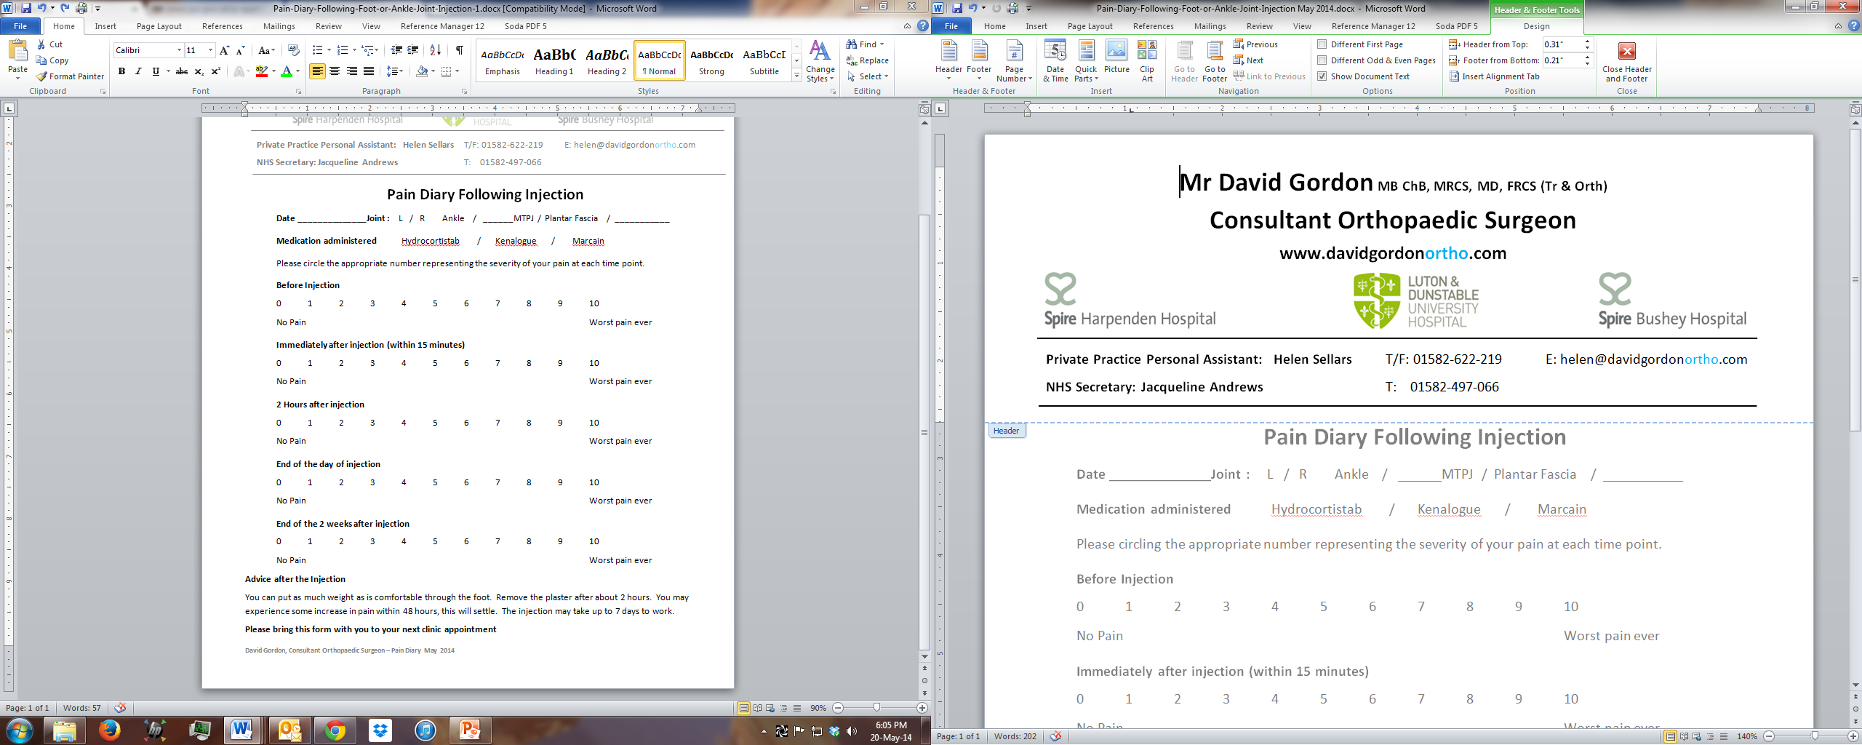

**Private Practice Personal Assistant: Helen Sellars T/F: 01582-622-219 E: helen@davidgordonortho.com**

**NHS Secretary: Christine Peters T: 01582-497-274 E:** [**christine.peters@ldh.n**](mailto:christine.peters@ldh.n)**hs.uk**

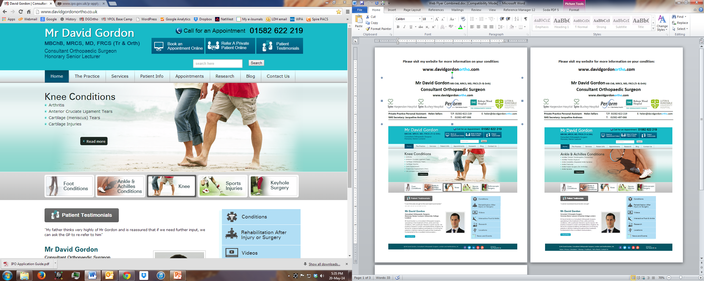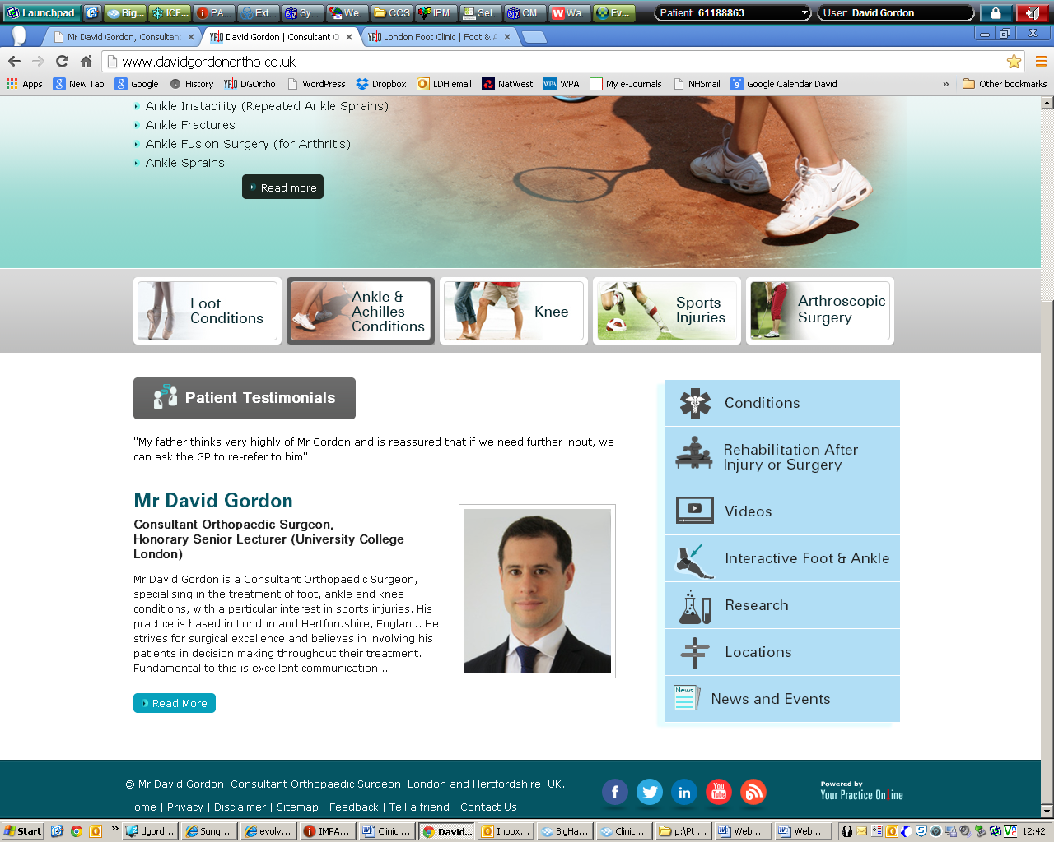

**Please visit my website for more information on your condition:**

**www.davidgordonortho.com**



**Private Practice Personal Assistant: Helen Sellars T/F: 01582-622-219 E: helen@davidgordonortho.com**

**NHS Secretary: Christine Peters T: 01582-497-274 E:** [**christine.peters@ldh.n**](mailto:christine.peters@ldh.n)**hs.uk**

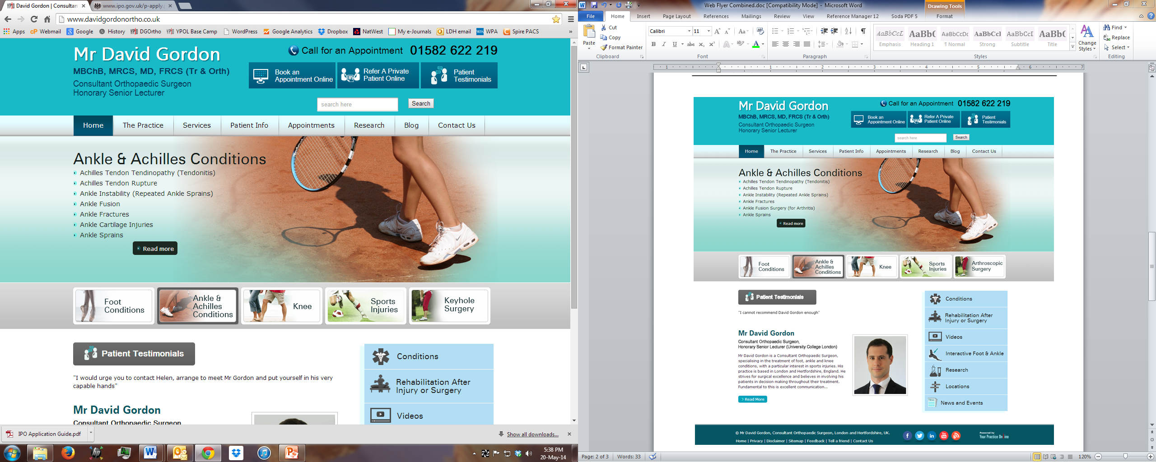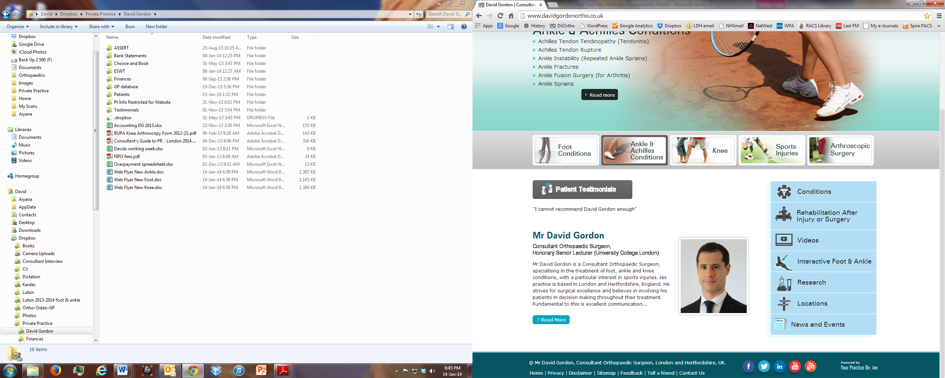

**Please visit my website for more information on your condition:**

**www.davidgordonortho.com**



**Private Practice Personal Assistant: Helen Sellars T/F: 01582-622-219 E: helen@davidgordonortho.com**

**NHS Secretary: Christine Peters T: 01582-497-274 E:** [**christine.peters@ldh.n**](mailto:christine.peters@ldh.n)**hs.uk**

